Resume
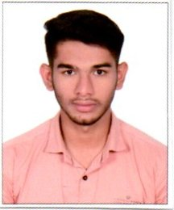

ABDUL RAOUFF
E-mail:abdulraouff45@gmail.com,

Mobile No: +971503101525
+916303529985.

CAREER OBJECTIVE

Seeking a career Oriented position with a Multinational or Professionally Managed Organization where my education and work experience is best utilized for dedicated corporate development. A position where talent, sense, responsibility, commitment, output of work required along with personal and professional growth is commensurate with achievements.

EXPERIENCE PROFILE:

Worked as Telecaller, bpo, call centre

~~~(Fine club executive) loan collection process ÷

Key responsibility ..
- Manage large amounts of inbound and outbound calls in a timely manner.
- Follow communication “scripts” when handling different topics.
- Identify customers' needs, clarify information, research every issue and provide solutions and/or alternatives.
- Great active listening skills

ACACDEMIC PROFILE:

- Graduation : Lords Institute Of Engineering And Tech
- Intermediate : Sri Medha V Junior College
- High schooling : Adarsh Vidayalaya High School

PROFESSIONAL SKILLS:
Well versed with all operations, Time management, teamwork, leadership, self-motivation , confidence & respect

COMPUTER SKILLS:
- Languages : Basic
- Operating System : Win 98,Xp 2000,2003,vista
- Packages : M. S Office (Words, Excel, Power Point)
PERSONAL PROFILE:
Name : ABDUL RAOUFF
Father’s Name : ABDUL GAFFAR
Date of Birth : 09-11-2000
Nationality : Indian
Marital Status : Single
Languages Known : English, Hindi and Telugu & urdu

(ABDUL RAOUFF)

Date:-

Place: Hyderabad

